# Report

# 吾心吾行澄如明镜 所作所为皆属正义

* 1. Network configuration
     1. A screenshot of the output from the command ip address on the router, web, files and desktop machines, respectively.

router

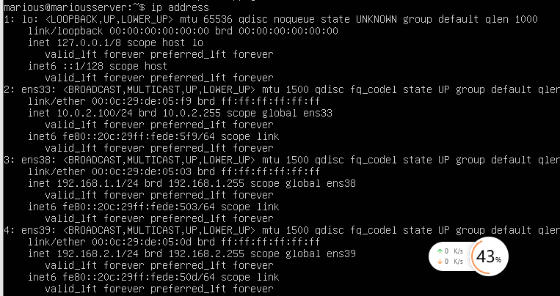

web

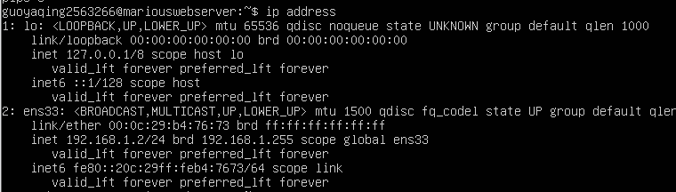

files

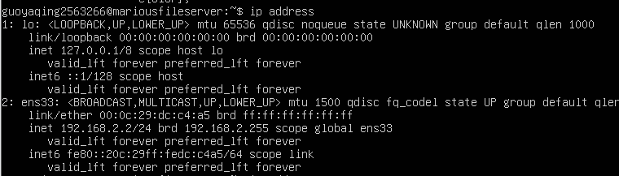

desktop

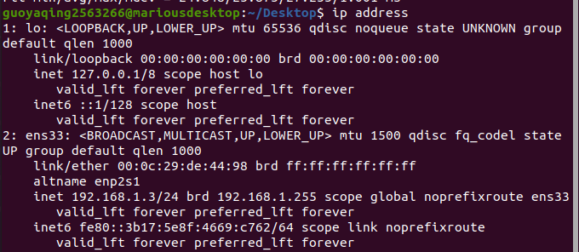

* 1. Routing configuration
     1. A screenshot of the output from the command cat

/etc/iptables/rules.v4 on the router machine.

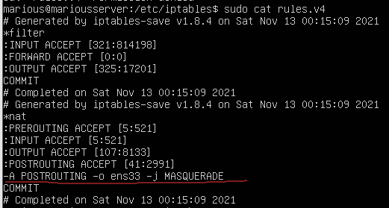

* + 1. A screenshot of the output from the command ping 192.168.1.2 on the

files machine and ping 192.168.2.2 on the web machine, respectively.

files machine

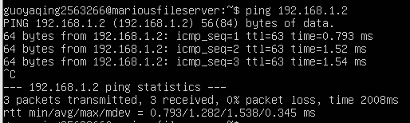

web machine

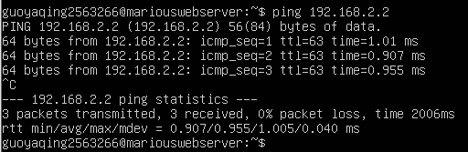

* 1. DNS service configuration
     1. Content of the file /etc/bind/named.conf.local and all forward and reverse zone files.

named.conf.local

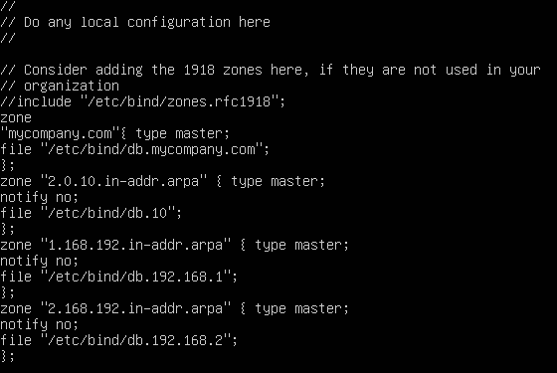

db.mycompany.com

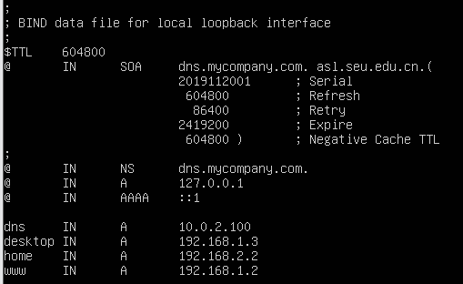

db.10

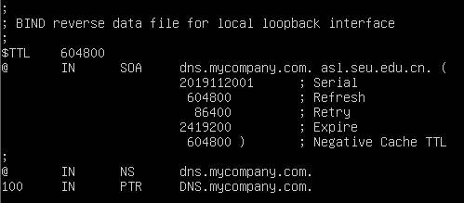

db.192.168.1

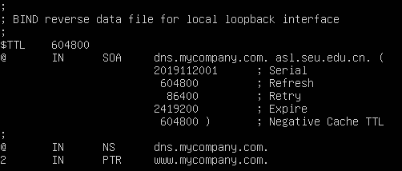

db.192.168.2

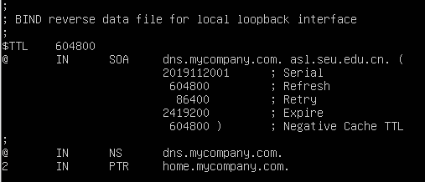

* + 1. A screenshot of the output from the command dig home.mycompany.com on the web machine and dig [www.mycompany.com](http://www.mycompany.com/) on the files machine, respectively.

web machine：

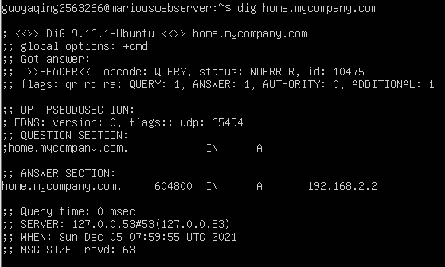

files machine

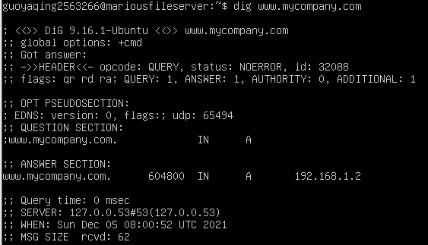

* + 1. A screenshot of the output from the command dig -x 192.168.2.2

@dns.mycompany.com on the web machine.

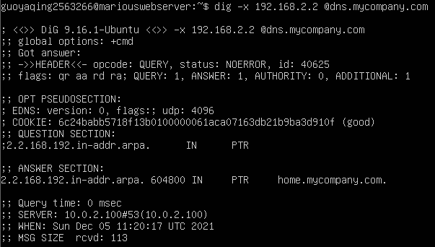

* 1. File system configuration
     1. A screenshot of the output from the command zpool status on the web

and files machines, respectively.

web

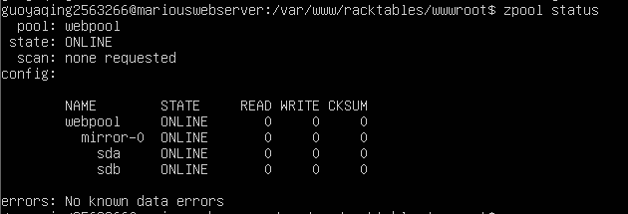

files

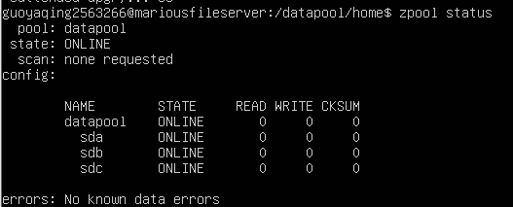

* + 1. A screenshot of the output from the command zfs list on the web and

files machines, respectively.

web

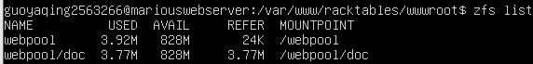

files

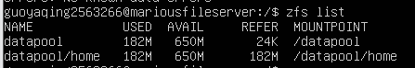

* + 1. A screenshot of the output from the command

showmount -e home.mycompany.com on the desktop machine.



* + 1. A screenshot of the output from the command cat /etc/fstab on the

desktop machines.

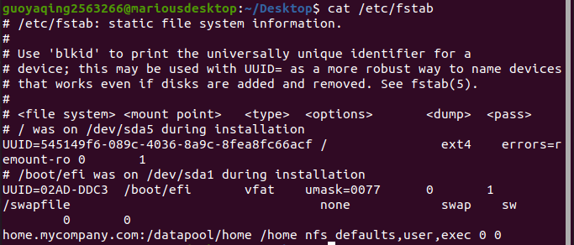

* 1. Web service configuration
     1. A screenshot of the output from the command

cat /etc/apache2/sites-available/000-default.conf on the

web machines.

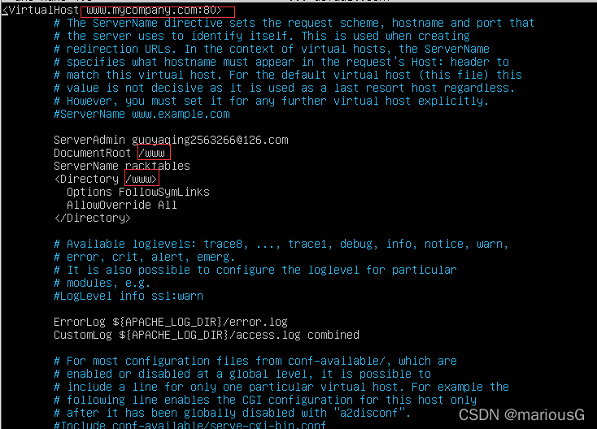

* + 1. A screenshot of your assignment web page on Firefox pointing to

[www.mycompany.com](http://www.mycompany.com/) on the desktop machine.

